- 1 -

**Fashion Shop Project report**

I

# Acknowledgement

# Table of Content

COVER PAGE

Approval I

Acknowledgement II

Dedication III

Table of Content IV

Abstract VI

CHAPTER ONE 1

* 1. INTRODUCTION 1
  2. BACKGROUND OF THE STUDY 2
  3. STATEMENT OF THE PROBLEM 4
  4. THE SOLUTION 5
  5. AIMS AND OBJECTIVES 5
  6. SCOPE AND LIMITATION 6
  7. RESEARCH METHODOLOGY 8
  8. SIGNIFICANCE OF THE STUDY 8
  9. DEFINATION OF TERMS 9
  10. CHAPTER LAYOUT 10

CHAPTER TWO: LITERATURE REVIEW 12

* 1. INTRODUCTION 12
  2. STATUS OF ONLINE SHOPPING IN PERSENT BUSINESS ENVIOURNMENT 12
  3. IMPORTANCE OF ONLINE SHOPPING 13
  4. PROBLEMS OF ONLINE SHOPPING 14
  5. THE FACTORS WHICH AFFECT ONLINE SHOPPING 14
  6. PRIVACY AND SECURITY ISSUES IN ONLINE SHOPPING 14

CHAPTER THREE 18

* 1. Methodology 18
     1. Introduction 18

3. 1. 2 Justification for the Methodology 18

3.2 SYSTEM ANALYSIS 20

* 1. Feasibility Study 20
  2. Requirements Analysis and Specification 23
     1. Requirements Gathering 23
     2. Data Collection Methods 23
     3. Requirements 24
     4. Input Specifications 27
     5. Output Specifications 30
     6. System Specifications 31
  3. SYSTEM DESIGN 31
     1. Process Flow 32
     2. Data Flow Diagrams 33
     3. Flow Chart 34
     4. UML Diagram 35
     5. Data Design 36
     6. Data Relationships 37

CHAPTER FOUR 38

RESULTS AND DISCUSION 38

CHAPTER FIVE 43

CONCLUSION AND RECOMMENDATION 43

CONCLUSION 43

RECOMMENDATION 43

APPENDIX 44

Project Log 44

Record of all procedures and Results 44

Structure of the Project Files 45

Templates Files 48

REFERENCES 49

# Abstract

Online Shopping play a great importance in the modern business environment. La BELLE Fashion Store has opened the door of opportunity and advantage to the firms. This paper analysed the different issue of online shopping. The research aims to provide theoretical contribution in understanding the present status of online shopping. The Study Discuss the consumers’ online shopping behaviours. Paper also identify the problems face by the consumers when they want to accept internet shopping. Present paper is an expressive study based on the detailed review of earlier pertinent studies related to the various concepts of online shopping to discover the concept of online shopping. Solitude and safety risk emerge regularly as a reason for being cautious about internet shopping. Shopping convenience, information seeking, social contact, and diversity affects the consumer attitude towards online shopping. The impossibility of product testing, problems with complaints, product return and missus of personal data are the main doubts regarding on-line shopping

# *Keywords:* Python, Django, SQL-lite3, Bootstrap 3, CSS, HTML, ecommerce, customer orders Fashion Shop

**LIST OF ABBREVIATIONS**

# Terminology Meaning

ERD Entity Relationship Diagram

DBD Database Diagram

DFD Data Flow Diagram

HTTP Hyper Text Transfer Protocol

SQL Structure Query Language

DBMS Database Management System

IDE Integrated Development Environment

# CHAPTER ONE

# INTRODUCTION

An E-commerce website requires appropriate strategy of successful design and implementation. Everything is required to plan from scratch to end of website. The e-commerce sector is seen the exponential growth thus a new option will easily part of this regatta of commercial website. The e-commerce website will feature the online shopping facility of various fashion products under a single web space. The proposed web application will allow business personnel to make their total business using it and increase their reachability thousands of times more than today they have, over the internet. It will allow multiple shopping vendors to sale their products online. The product management in the system will be done in the form of categories. The safety of information is the main requirement of the system and will be handling according to that. To formulate this project first task is to do is cost estimation. For probabilistic assessment of the project cost estimation is required. Cost estimation covers the accurate; estimations of cost and effort required for the project.

As a project manager and developer as well, it’s is estimates are defined to early stage in the project. Cost estimation in application development project includes the set of procedures and techniques that will be utilized, required to produce by organisation for development (Alex,2013). The available resources of a company are also affecting the cost estimation. It will be very complex project. To demonstrate knowledge learnt in class, tech communities and online materials, I will undertake the entire project alone even though it requires a team of 6 or more. It will take time of 3months to get the shape or get the basic structure. The environment variants depend on the further requirements of the ecommerce web application.

1

# BACKGROUND OF THE STUDY

The traditional marketing and management of fashion industry is experiencing a revolution because of the emergence of e-commerce. Since the birth of e-commerce, businesses have been able to make use of the Internet in reducing costs associated with purchasing, managing supplier relationships, streamlining logistics and inventory, and developing strategic advantage and successful implementation of business re-engineering. E-commerce allows companies to improve communications within the supply chain and enhance service offering, thus providing chances for competitive differentiation.

Fashion is a distinctive and often habitual trend in the style in which a person dress. It is the prevailing styles in behaviour and the newest creations of textile designers. *Fashion design* is influenced by cultural and social latitudes, and has varied over time and place. Fashion designers attempt to design clothes which are functional as well as aesthetically pleasing. They must consider who is likely to wear a garment and the situations in which it will be worn. Anthropology, the study of culture and human societies, studies fashion by asking why certain styles are deemed socially appropriate and others are not. A certain way is chosen and that becomes the fashion as defined by a certain people as a whole, so if a particular style has a meaning in an already occurring set of beliefs that style will become fashion. According to Ted Polhemus and Lynn Procter (2008), fashion can be described as a beautification. Fashion changes very quickly and is not affiliated with one group or area of the world but is spread out throughout the world wherever people can communicate easily with each other.

The fashion industry is a product of the modern age. Historically, prior to the mid-19th century, most clothing was custom-made. It was handmade for individuals, either as home production or on order from dressmakers and tailors. By the beginning of the 20th century with the

rise of new technologies such as the sewing machine, the rise of global capitalism and the development of the factory system of production, and the proliferation of retail outlets such as department stores clothing had increasingly come to be mass-produced in standard sizes and sold at fixed prices.

Although the fashion industry developed first in Europe and America, as of 2014 it is an international and highly globalized industry, with clothing often designed in one country, manufactured in another, and sold world-wide. For example, an American fashion company might source fabric in China and have the clothes manufactured in Vietnam, finished in Italy, and shipped to a warehouse in the United States for distribution to retail outlets internationally. The fashion industry has long been one of the largest employers in the Kenya, and it remains so in the 21st century (from Mitumba sellers to custom made tailors). However, Kenyan government declined considerably as production increasingly shipped from overseas, especially from China. Instead, they encourage people to buy Kenyan made fashion products under the slogan *“Buy Kenya, Build Kenya.”* Because data on the fashion industry typically are reported for national economies and expressed in terms of the industry’s many separate sectors, aggregate figures for world production of textiles and clothing are difficult to obtain. However, by any measure, the clothing industry accounts for a significant share of world economic output.

The fashion industry consists of four levels:

* The production of raw materials, principally fibres and textiles but also leather and fur.
* The production of fashion goods by designers, manufacturers, contractors, and others.

**___________________COM/O42/16____________________**

* Retail sales.
* Various forms of advertising and promotion.

These levels consist of many separate but interdependent sectors. These sectors are Textile Design and Production, Fashion Design and Manufacturing, Fashion Retailing, Marketing and Merchandising, Fashion Shows, and Media and Marketing. Each sector is devoted to the goal of satisfying consumer demand for apparel under conditions that enable participants in the industry to operate at a profit. La BELLE Fashions falls under the retail category and truly need an ecommerce website to market and sell their products. The ecommerce system will make their daily operations and customer service efficient, error free and effective.

# STATEMENT OF THE PROBLEM

Traditionally, customers are used to buying the products at the real, in other words, factual shops or supermarkets. It needs the customers to show up in the shops in person, and walk around different shopping shelves, and it also needs the owners of shops to stock, exhibit, and transfer the products required by customers. It takes labour, time and space to process these operations.

Furthermore, the spread of the Covid-19 pandemic has caused a lot of changes in our lifestyle, people fearing to get outside their homes, transportation almost shut down and social distancing becoming all the more important. Big to small scale business that relied on the traditional incur a lot of consequence due to the lockdown issues. Some tend to more towards using social media platforms like Facebook to sell their product. However, the social media platforms have been beneficial for marketing purposes alone but leaves the whole task of customer and massive order management via direct messaging (DM), which takes a lot of time to respond to all customers. In

addition, everyone tends to use social media, posing a great challenge to differentiate between scammers (fraudsters) and legit sellers.

# THE SOLUTION

La BELLE Fashions Store is an **Online shopping** system provides a solution to reduce and optimize these expenses. Authorized Customers do not need to go to the factual shops to choose, and bring the products they need by hands. They simply browse their Personal computers or cell phones to access shops, and evaluate the products description, pictures on the screen to choose products. In addition, the owners of the shop do not need to arrange or exhibit their stocks products. They just input the description, prices of products, and upload their pictures. Simply, both customers and shop owners do not need to touch the real products in the whole process of shopping, and management. In the end the logistic centre will distribute the products required by customers, or products ordered by shop owners to their locations. The customers are able to track the status of their orders until delivery, after which they can leave a review of the type of service they received. The payment and products’ quantity will be saved in database through the data flow. These shopping, management and distribution processes greatly simplify and optimize the retail business.

# AIMS AND OBJECTIVES

The main objective of the study is to develop an online fashion brochure system. The system aims to achieve the following objectives:

* + - To design an online fashion system.
    - To provides a solution to reduce and optimize the expenses of customer order management
    - To create an avenue where people can shop for fashion products online.
    - To develop a database to store information on fashion products and services.

# SCOPE AND LIMITATION

Every project is done to achieve a set of goals with some conditions keeping in mind that it should be easy to use, feasible and user friendly. As the goal of this project is to develop an online fashion brochure system, this system will be designed keeping in mind the conditions (easy to use, feasibility and user friendly) stated above. It may help in effective and efficient order management. In every shot time, the collection will be obvious, simple and sensible. It is very possible to observe the customer potentials and purchase patterns because all the ordering history is store in the database. It is efficient managing all the operations of an online store within a single platform. The project aims to automate the business process of La BELLE Fashion store. The proposed project would cover:

**Customer Side**

* + - Customer can view/search products without login.
    - Customer can also add/remove product to cart without login (if customer try to add same product in cart. It will add only one)
    - When customer try to purchase product, then he/she must login to system.
    - After creating account and login to system, he/she can place order.
    - If customer click on pay button, then their payment will be successful and their order will be placed.
    - Customer can check their ordered details by clicking on orders button.
    - Customer can see the order status (Pending, Confirmed, Delivered) for each order
    - Customer can Download their order invoice for each order
    - Customer can send feedback to admin (without login)

**Administrator Side**

* + - Admin can provide username, email, password and your admin account will be created.
    - After login, there is a dashboard where admin can see how many customers is registered, how many products are there for sale, how many orders placed.
    - Admin can add/delete/view/edit the products.
    - Admin can view/edit/delete customer details.
    - Admin can view/delete orders.
    - Admin can change status of order (order is pending, confirmed, out for delivery, delivered)
    - Admin can view the feedbacks sent by customers

Additionally, if customer places order and admin deleted that user (fraud detection), then their orders will automatically be deleted. Suppose one (1) customer places four (4) products order and admin deleted two (2) product from website, then that two-product order will also be deleted and other two will be there. Also, if user click on purchase button without having products in their cart, then website will ask to add product in cart first.

On the contrary, designing web applications is characterized by some constraints and limitations. Developers are limited to a small set of graphical widgets for use in presenting a user interface. Web-based applications require high investment in software, as well as maintenance costs for the software and personnel for software administration. In this study, verification of credentials for membership cannot be done. Besides, there is a payment page although just for demo.

Customers are advised to fill in pseudo details (DONT FILL YOUR ORIGINAL CARD DETAILS THERE). By the way, website do not save these details.

# RESEARCH METHODOLOGY

The research method used for this project work is quantitative research reviews the current system, provide its description, identifying the discrepancies and eventually giving a suitable solution. Therefore, the method used in the design and collections of information from various sources are as follows:

* + - Studying the present system in detail and the organizational style.
    - Knowing and understanding the input and output processes of the existing system.
    - A qualitative form of interview was conducted in the organization to understand the mode of operation of the old system.

# SIGNIFICANCE OF THE STUDY

With the aid of an efficient information system, fashion associations can be able to react quickly by giving out information about changes in the market and latest trends to the public. An online application not only saves time and money, but also minimizes administrative efforts and cost. It provides an avenue to market products to a whole new audience. Here are benefits of having an La BELLE Fashion brochure system;

* + - Easy advertisement of new products and services
    - Saves time on the part of the buyer due to the fact that they can do transactions for any product or make enquiries about any product or services provided by a company anytime and anywhere.
    - It creates an avenue for expansion to national and international markets.
    - An online fashion brochure system improves the brand image of a company.
    - It aids a fashion company in providing better customer service.
    - It helps to simplify business processes and make them faster and more efficient.

# DEFINATION OF TERMS

* + - **Fashion:** fashion is a distinctive and often habitual trend in the style in which a person dress.
    - **Fashion design:** fashion design is the art of the application of design and natural beauty to clothing and accessories.
    - **Fashion designer:** a fashion designer is someone who loves to study fashion trends, sketch designs, select materials, and have a part in all the production aspects of their designs. they contribute to the creation of millions, if not billions of pieces of clothing and accessories purchased by consumers on a yearly basis. fashion designers create women’s, men’s and children’s apparel. this might include sportswear, maternity wear, outerwear, underwear, formalwear, eyewear and footwear. there are also accessory designers who design belts, scarves, hats, handbags and hosiery.
    - **Association:** an association is an organized body of people who have an interest, activity, or purpose in common; a society.
    - **Web based application:** a web-based application is a software package that can be accessed through the web browser. the software and database reside on a central server rather than being installed on the desktop system and is accessed over a network.
    - **Web browser:** a web browser is a software application used to enable computer users locate and access web pages.
    - **Brochure:** a brochure is an advertising piece mainly used to introduce a company or an organization and inform about products or services to a target audience.
    - **E-commerce:** electronic commerce is the buying and selling of goods and services, or the transmission of funds or data, over an electronic network, primarily the internet.
    - **Catalogue:** a product catalogue is a file that contains a list of all the products you want to advertise. Each line of the product catalogue contains a description of each product, including an id, name, category, availability, product URL, image URL and other product attributes.

# CHAPTER LAYOUT

The chapter layout of this project is outlined in a sequential manner starting with Chapter one which consists of the Introduction, Background of the study, Statement of the problem, Aims and objectives, Justification and Significance of study, Research methodology, and Scope, Limitation.

Following this chapter, the rest of the paper proceeds as follows. Chapter two consist of introduction, Literature review of the project, an overview of ecommerce applications. Chapter three deals with the Methodology. It comprises of analysis of the existing system under which description of the current system will be analysed, problems of existing system, description of the proposed system and the advantages of the proposed system. It also highlights the system design, system implementation and system documentation under the system design, the system design will have input and output specifications. Chapter four describe the results and discussion of the study. Chapter five will include summary, conclusion and recommendation. It consists of the summary of the project

report, conclusion and recommendation based on the research done and achievable outcomes.

# CHAPTER TWO: LITERATURE REVIEW

# INTRODUCTION

Literature review is an expressive study based on the detailed review of earlier pertinent studies related to the various concepts of online shopping to discover the concept of online shopping. It highlights the status of online shopping, importance and problems of online shopping, factors affecting online shopping and a critical review of the privacy and security issues in online shopping.

# STATUS OF ONLINE SHOPPING IN PERSENT BUSINESS ENVIOURNMENT

Online buying behaviour is affected by various factors like, economic factors, demographic factors, technical factors, social factors, cultural factors, psychological factors, marketing factors and legislative factors. Customers choose an online-shop mainly based on references, clarity terms of delivery, graphic design and additional services. Problematical customers read discussions on the Internet before they spend their money on-line and when customers are incapable to purchase the product fast and with no trouble they leave online-shop. Kotler, (2003) described Consumer buying method as learning, information-processing and decision-making activity divided in several consequent steps: Problem identification, Information search, Alternatives evaluation, Purchasing decision, Post-purchase behaviour. Euthymia identified the main constituent of the online shopping experience as follows: the functionality of the Web site that includes the elements trade with the site’s usability. the emotional elements planned for lowering the customer’s hesitation by communicating trust and credibility of the online seller and Web site and the content elements including the aesthetic aspects of the online presentation and the marketing mix. Usability and trust are the issues more regularly found to influence the online consumer’s behaviour. Karayiannis, (2 examined that discriminating of potential determinants between web- shoppers and non-shoppers. Free shipping is a great motivator to purchase the products and customers are willing to pay nominal

charges for getting their products. While compare the shopping with others shopping, consumers take product price and shipping charges almost equally into deliberation. There are some ways that retailers can do to improve the experience for their online shoppers. The first is to write the expected delivery date of the order, customers are willing to wait for their orders but want to know just how long that force is. Timely coming of product shipment encourages shoppers to recommend an online retailer. Consumers also want to track updates and delivery notifications to understand when their package is incoming. Online shoppers want flexibility in their shipping, mainly the ability to give special delivery instructions or schedule a delivery time. Customers are also wanting to get the address changing option for filling the wrong address when they are purchasing online.

# IMPORTANCE OF ONLINE SHOPPING

Ling, said that customers can take enjoy online shopping for 24 hour per day. Consumers can purchase any goods and services anytime at everywhere. Online shopping is user friendly compare to in store shopping because consumers can just complete his requirements just with a click of mouse without leaving their home. Online shopping has some advantages like below

* + - Save the Time of the consumers.
    - They can purchase any time anywhere
    - They can compare the price with the others retailers very easily.
    - Compare the advertising price and actual price
    - They can easily track their product
    - They can use cash back policy
    - They can purchase the product from the foreign marketers.

# PROBLEMS OF ONLINE SHOPPING

Online shopping problems are great barrier to the online purchase aim of customers. General problems include prospect of having credit card. The obscurity to confirm the reliability of the provide goods and the risk to buy a product that it would not value as much as customer pay for it. Aftersales problems, involved difficulty to change not working product with a new one and products warranty are not assured. Online shopping has various disadvantages:

* + - The customers can not touch and fell of the products when they want to Purchase.
    - Some time delivery time is so much late
    - Some time they will pay the shipping charges so why the cost of the product may increase.
    - Lack of personal attention by the sellers. More chance to fraud.
    - Security of internet banking password and credit card password
    - Lack of quality

# THE FACTORS WHICH AFFECT ONLINE SHOPPING

There are some factors which affect the online shopping by the Kotler who is a great marketing writer

* + - Convenience (no traffic, crowds,24 hr. access
    - Product Selection
    - 3. Delivery Mode

# PRIVACY AND SECURITY ISSUES IN ONLINE SHOPPING

Shopping online has never been so easy. With the flourishing numbers of online merchants, people nowadays have various choices to do their shopping. Big companies such as eBay and amazon.com have introduced many values added features to help the customers to decide what to

shop for. With features such as price comparison, product photos and user reviews, consumers can shop easily and smartly without even going to the stores and having such a hard time looking for the products they want. All they have to do are just browse for the product they want in the website and within a few mice clicks they are off. Such simplicity is what makes online shopping appealing for consumers. The question is, why do many people still deny to shop online? Well, for most people, privacy and security issues are their concerns. Hence, here I will discuss customers’ perception of privacy and security issues, the reality of such issues and ways to avoid those issues, all based on some trustworthy sources I have found.

To know customers’ perception of customer and security issues, I reviewed a scholarly article entitled “Consumer Perceptions of Privacy and Security Risks for Online Shopping” produced in the Journal of Consumer Affairs. In the United States, more than half of the adult population uses the Internet and from that number, approximately half have shopped online (Sefton, qtd. in Miyazaki and Fernandez 28). Previous studies had shown that Internet users as a whole agreed that privacy and security issues are vital for them to shop online (Rohm and Milne, qtd. in Miyazaki and Fernandez, n.d). Most of them regard their personal information as their main concern (U.S. FTC, qtd. in Miyazaki and Fernandez, n.d). In the research conducted by Miyazaki and Fernandez, who are the authors of the articles themselves, privacy and security issues accounted for more than 65 percent of consumers’ main concern as oppose to the other 35 for shopping inconveniences and others (Fernandez et al., n.d). They also concluded that more experienced Internet users tend to have more concern regarding privacy issues but less concern on security issues. Nevertheless, consumers still consider both as their main concern for online shopping as suggested in the survey.

Now, after knowing that privacy and security issues are vital for consumers in online shopping, I would like to know the emphasis in the real world. From an article titled “The Myth of Secure E-Shopping” published in PC World, the reality of such issue is revealed. While most

consumers trust big and well-established online merchant such as CD Universe, Travelocity, Columbia House and Ikea, these big companies still receive frequent security threats (Kandra, 2001). Joseph McDonnell, a CEO of online security firm IShopSecure even confessed that all online firms must have received threats of some sorts (Kandra, 2001). He added by saying that hackers could easily infiltrate and get customers personal information online as online shoppers are not anonymous. According to Kandra, experts also discover that security measures taken by online retailers are insufficient. For instance, data encryption only applies in actual transfer of customer data but not in the database which is ironically the most common targets for hackers. Some other sites however, do not even have privacy and security policy posted implying that they do not protect their customers (Hairell, 2011). Kandra posits that this is what happened to eBay when it was hacked hence compromising its customers’ credit information. Apart from the retailers themselves, credit card processing firms and third-party sites also receive threats. Creditcards.com once had disclosed that someone had infiltrated its site and posted more than 55000 credit card numbers on the Internet. So, from all these indications, I can see that online shopping is not totally safe.

However, customer rights and security aspects are not just the responsibility of online

merchants. To uphold them, the consumers themselves need to act. According to “Ten Things Your Mother Never Told You About Online Shopping” published in Yahoo! Internet Life, to be an ace consumer, online shoppers need to prepare themselves with some basics (Halpin, 2011). As the prominent method of payment is credit card, consumers should be more aware in handling it. They should never disclose their credit information via e-mail. Some of the credit card issuers also have some sorts of protection that consumers should apply for. Apart from that, consumers should limit themselves from releasing unnecessary personal information such as age and income to protect their privacy (Hood & Halpin, 2011). Also, as Todd Richter who is the president of Girl shop (an e- commerce site) had said, consumers should always be aware of the security technology used by

merchant sites. Technologies such as Secure Socket Layer (SSL) and VeriSign play vital part in distinguishing one site from another. Nonetheless, consumers should always be alert of the privacy and customer policy in each site they tend to buy from (Halpin, 2011). Lastly, if there are still dissatisfactions, consumers could always report them to consumer-related agencies such as Better Business Bureau or Federal Trade Commission (Halpin, 2011).

Thus, after reviewing these three reliable sources related to the privacy and security issues of online shopping, I can see some interconnections between them. By common sense, anyone who tends to shop online will think twice before they buy anything as to consider the privacy and security issues related to it. This is proven in my first source (“Consumer Perceptions of Privacy and Security Risks for Online Shopping”) through the survey. People are always conscious about their privacy and security. However, this is not the case in the real world. As my second source (“The Myth of Secure

E-Shopping”) has proposed, even though online merchants have tried their best to beef up the security, threats and attacks still prevail. For this reason, consumer should act fast to protect their privacy when shopping online. My third source (“10 Things Your Mother Never Told You About Online Shopping”) explains many ways that consumers could do to enhance the privacy and security aspect apart from what online merchants have done for the same reason. Taking all these contents as a whole, I would say that in any situation, people can still shop online safely provided they understand the reality and take some precautions above all.

# CHAPTER THREE

# Methodology

# Introduction

This Section describes the methodology applied during the development of la BELLE Fashions store. A methodology is a model, which project managers employ for the design, planning, implementation and achievement of their project objectives. Effective project management is essential in absolutely any organization, regardless of the nature of the business and the scale of the organization. From choosing a project to right through to the end, it is important that the project is carefully and closely managed. Based on the nature of my project solution, it was essential to use incremental Software development life cycle (SDLC). The project typically has a number of Phases and the level of control required over each phase are primarily defined by the nature of the Project, the complexity of the same and the industry to which the Project has to cater to. An Incremental (SDLC) model consists of a number of dependent increments that are completed in a prescribed sequence. Each increment includes a Launching, Monitoring and Controlling, and Closing Process Group for the functions and features in that increment only. Each increment integrates additional parts of the solution until the final increment, where the remaining parts of the solution are integrated.

# 1. 2 Justification for the Methodology

This model can be used when the requirements of the complete system are clearly defined and understood, like the case of this project where;

* + Major requirements were evidently defined; however, some details evolved with time.
  + There was a need to complete the project within a short time schedule.
  + A new technology is being used or the resources with needed skill set are not available. I was learning Flask and Django and could iterate from one technology to another to ensure I effective implement all the functionalities.
  + The project had some high-risk features and goals.

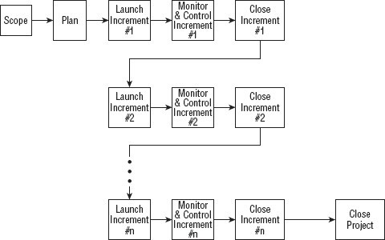

*Figure 1: Incremental Project Management Life Cycle*

The Incremental model is much better equipped to handle change. Each incremental functionality is verified by the customer and hence the relative risk in managing large and complex projects is substantially reduced. On the downside, there is a possibility of gold plating, wherein the functionalities not really required end up being built into the Product or Deliverable. In a nutshell, Incremental SDLC provide plethora of advantages inducing;

* + - Generates working software quickly and early during the software life cycle.
    - This model is more flexible and less costly to change scope and requirements.

**___________________COM/O42/16____________________**

* + - It is easier to test and debug during a smaller iteration.
    - In this model customer can respond to each built.
    - Lowers initial delivery cost.
    - Easier to manage risk because risky pieces are identified and handled during it’d

iteration.

# SYSTEM ANALYSIS

Analysis is an important part of any project; is analysis is not done properly then whole project move in the wrong direction. It also provides a schedule for proper project work. Analysis

task divided into 3 areas:

* + - Problem Recognition.
    - Feasibility Study.
    - Requirement Analysis.

# Feasibility Study

Feasibility study of the system is a very important stage during system design. Feasibility study is a test of a system proposal according to its workability impact on the organization, ability to meet user needs, and effective use of resources. Feasibility study decides whether the system is properly developed or not. There are five types of feasibility as mentioned below:

1. Technical Feasibility
2. Time Schedule feasibility
3. Operational feasibility
4. Implementation feasibility
5. Economic Feasibility

# Technical Feasibility

Technical feasibility corresponds to determination of whether it is technically feasible to develop the software. Here those tools are considered, which will be required for developing the project. The tools, which are available, and tools, which will be required, are taken into account. Considering all above points and aspects it is observed that the cost incurred in developing this project from a technical perspective would not be too high. Thus, it is feasible for company as well as for me to develop this system.

# Time Feasibility

Time feasibility corresponds to whether sufficient time is available to complete the

project.

**Parameters considered:**

* Schedule of the project.
* Time by which the project has to be completed.
* Reporting period

Considering all the above factors it was decided that the allotted time that is 3 months was sufficient to complete the project.

1. **Operational Feasibility**

Operational feasibility corresponds to whether users are aware of interface environment and sufficient resources are available or not.

**Parameters considered:**

* People with a basic knowledge of computers would be able to use our system very effectively and easily, as the system would have an intuitive **GUI**. The director and employees of La BELLE Fashions have a basic operating knowledge of computers, so

understanding the working of the system and using it would be easy from the decision

maker’s point of view.

* All the relevant necessary resources for implementing and operating this system are already present in office.

Bearing in mind the above factor, it was observed that the cost would be incurred in developing this project from an operational standpoint would be low. Thus, it would be operational feasible for the company.

# Implementation Feasibility

Implementation Feasibility is about basic infrastructure required to develop the system. Considering all below points, it is feasible to develop system.

**Factors considered**:

* All the minimum infrastructure facility required like PC, books, technical manuals are provided.
* Proper guidance is provided.
* All necessary data and files are provided.

# Economic Feasibility

Economic Feasibility is about total cost incurred for the system. The software resource requirement of the proposed system is Django and SQLite for functional and backend development and HTML, CSS, JS for the frontend UI.

# Requirements Analysis and Specification

A complete understanding of software requirement is essential to the success of a web- development effort. No matter how well designed or well coded, a poorly analysed and specific program will disappoint user and bring grief to the developers.

The requirement analysis task is process of discovery, refinement, modified and specification. The software scope, initially established by the system engineer and refined during project planning, is refined in detail. Models of the required data, information and control flow, and operational behaviour are created. Alternative solutions are analysed and various project element.

Currently who want to buy some shoes or any clothing type they have to go to the shop and buy them this is very tedious for customer therefore we upload this site on internet. This web-site should be developed with an aim to simplify shopping process and keeping transparency and flexibility in performing each operation.

# Requirements Gathering

Also known as data collection. Data Collection is an important aspect of any type of research study. Inaccurate data collection can impact the results of a study and ultimately lead to invalid results. The methods used to gather the projects requirements involves Quantitative research to review the existing systems in the market.

# Data Collection Methods

This study used quantitative techniques like online survey and questionnaire. Qualitative data collection methods play an important role in impact evaluation by providing information useful to understand the processes behind observed results and assess changes in people’s perceptions of their well-being. Furthermore, qualitative methods can be used to improve the quality of survey- based quantitative evaluations by helping generate evaluation hypothesis; strengthening the design

of survey questionnaires and expanding or clarifying quantitative evaluation findings. These methods are characterized by the following attributes:

* They tend to be open-ended and have less structured protocols
* They rely more heavily on interactive interviews; respondents may be interviewed several times to follow up on a particular issue, clarify concepts or check the reliability of data
* They use triangulation to increase the credibility of their findings
* Generally, their findings are not generalizable to any specific population, rather each case study produces a single piece of evidence that can be used to seek general patterns among different studies of the same issue

Existing written and visual materials were assessed to find important data and information towards the development of the system. Information about appointment managements, patient’s management were collected. During data collection, the investigation found out how the current system operates, not only that but also tried out which problems are faced and how best they can be settled.

Requirement analysis and specification may appear to be relatively simple task, but appearances are deceiving. Communication content is very high, chances for misinterpretations or misinformation abound. Ambiguity is probable. The dilemma that confronts a software engineer may best be understood by repeating the statement of an anonymous customer: “I know you

believe you’re understood what you think I said, but I am not sure you realize that what you heard is not what I meant”.

# Requirements

The requirements form the proposed system was categorized into functional and non- functional requirements.

## Functional Requirements

The following is the desired functionality of the new system. The proposed project would

cover:

**Customer Module**

* + - * Customer can view/search products without login.
      * Customer can also add/remove product to cart without login (if customer try to add same product in cart. It will add only one)
      * When customer try to purchase product, then he/she must login to system.
      * After creating account and login to system, he/she can place order.
      * If customer click on pay button, then their payment will be successful and their order will be placed.
      * Customer can check their ordered details by clicking on orders button.
      * Customer can see the order status (Pending, Confirmed, Delivered) for each order
      * Customer can Download their order invoice for each order
      * Customer can send feedback to admin (without login)

**Admin Module**

* + - * Admin can provide username, email, password and your admin account will be created.
      * After login, there is a dashboard where admin can see how many customers is registered, how many products are there for sale, how many orders placed.
      * Admin can add/delete/view/edit the products.
      * Admin can view/edit/delete customer details.
      * Admin can view/delete orders.
      * Admin can change status of order (order is pending, confirmed, out for delivery, delivered)
      * Admin can view the feedbacks sent by customers

## Non-functional Requirements

It specifies the quality attribute of a software system. They judge the software system based on Responsiveness, Usability, Security, Portability and other non-functional standards that are critical to the success of the software system.

* **Availability:** The system should remain operational in any day and any place.
* **Accuracy:** There is a need to optimize the system to ensure more accurate results and calculations.
* **Usability:** The system should provide a User-friendly user interface and tooltips to enhance itself and be effectively responsive.
* **Secure:** The system must be able to provide security against any external injections by using a layered security system. Implementation of user login functionalities also ensures the system is secure from unauthorized persons.
* **Performance of the system:** Response time is very good for given piece of work. The system will support multi user environment.
* **Reliability of the system:** The system will be highly reliable and it generates all the updates information in correct order. Data validation and verification is done at every stage of activity. System recovery will also be speed.

# Input Specifications

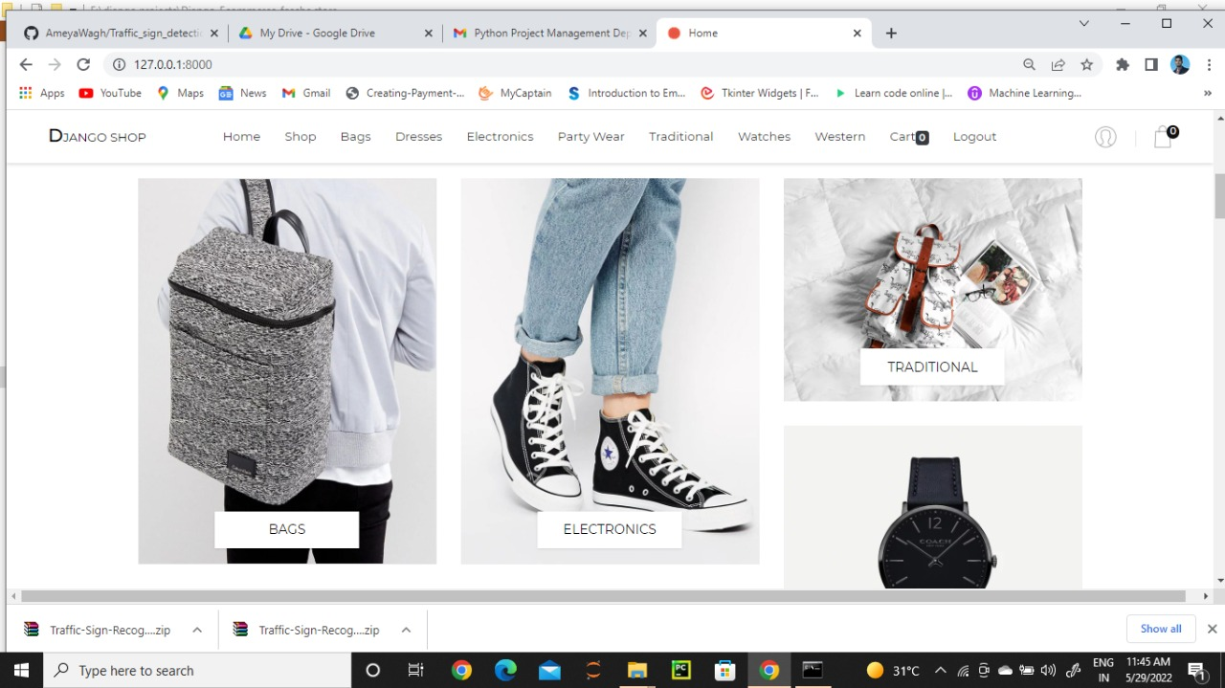

*Home*

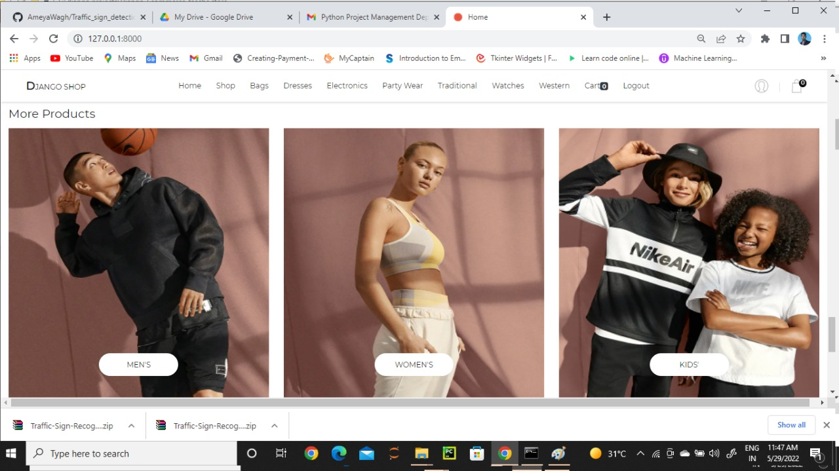

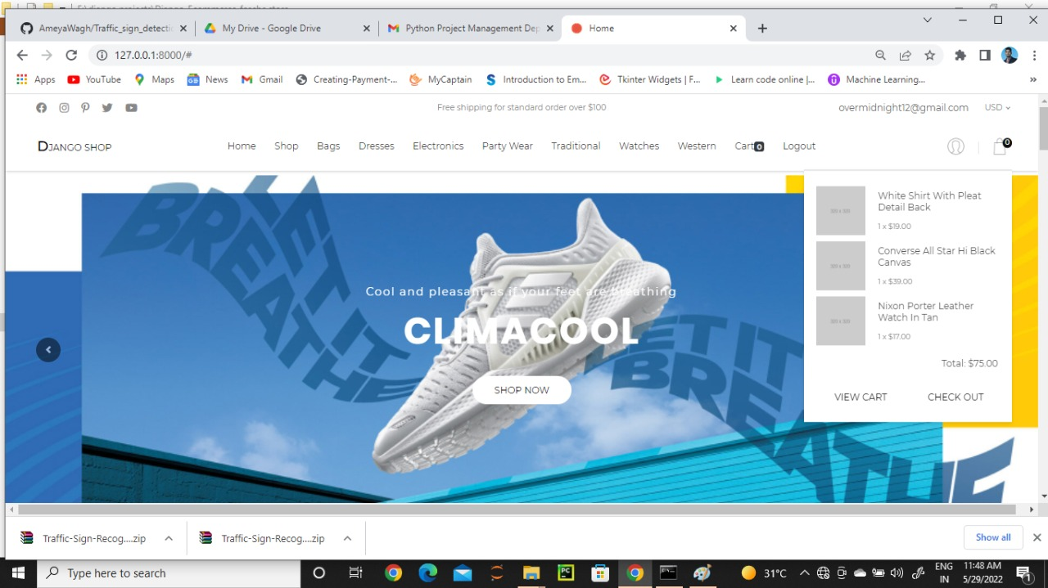

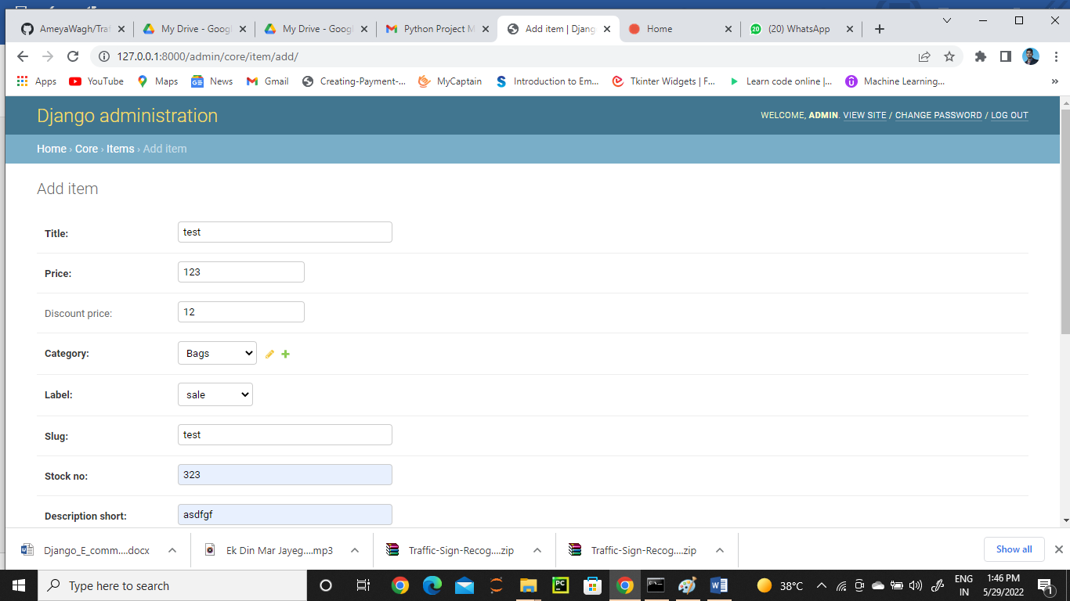

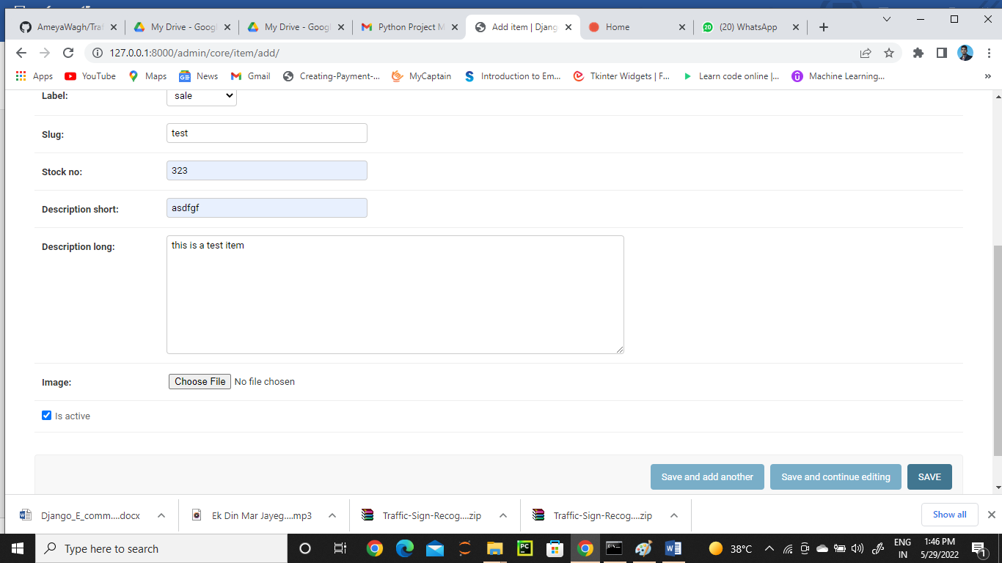

*Figure 4: Admin add products*

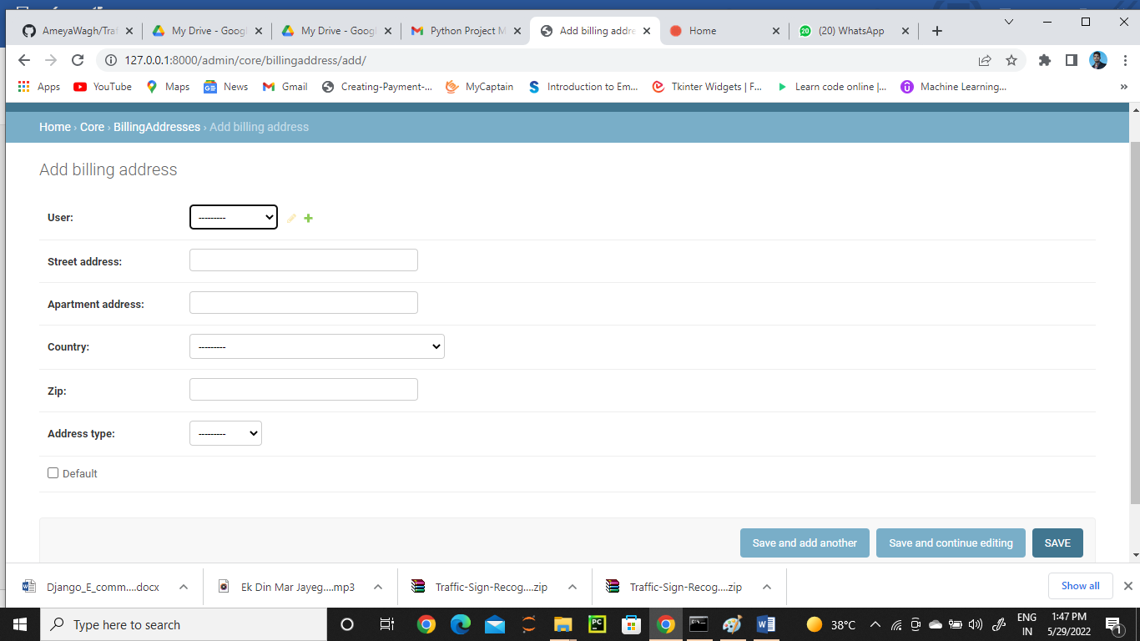

*Figure 5: admin add shipment details*

# System Specifications

This section describes the hardware components and software requirements needed for effective and efficient running of the system

# Table: 1 Hardware Requirements

|  |  |  |
| --- | --- | --- |
| **SL** | **Hardware** | **Minimum System Requirement** |
| 01 | Processor | 2.4 GHz Processor speed |
| 02 | Memory | 2 GB RA |
| 03 | Disk Space | 500 GB |

**Table: 2 Software Requirements**

|  |  |  |
| --- | --- | --- |
| **SL** | **Software** | **Minimum System Requirement** |
| 01 | Operating System | Windows 8, Windows 10 or MAC Ox 10.8,10.9, or 10.11, LINUX |
| 02 | Database Management System | SQL Lite 3 |
| 03 | Runtime Environment | PyCharm or Visual Studio Code |

# SYSTEM DESIGN

The section describes the system study, analysis, design strengths and weaknesses of the current system, Contest level diagrams, Entity Relationship Diagram, Architectural design. After interpretation of the data, tables were drawn and process of data determined to guide the researcher of the implementation stage of the project. The tools, which were employed during this

methodology stage, where mainly tables, Data Flow Diagrams and Entity Relationship Diagrams. The design ensures that only allows authorized users to access the systems information.

# Process Flow

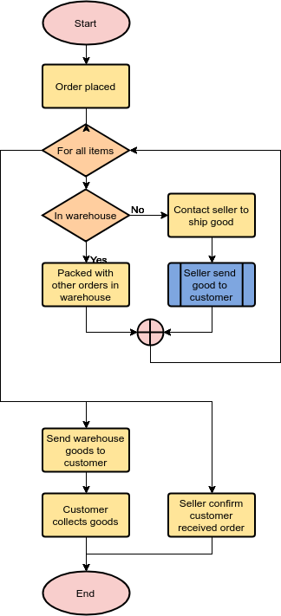

*Figure 8: Process Flow Diagram*

# Data Flow Diagrams

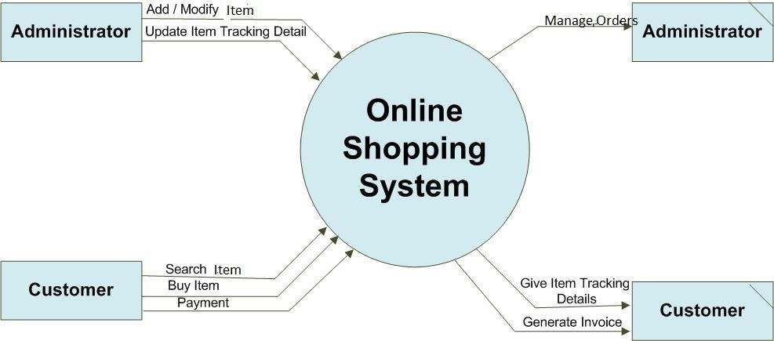

*Figure 9: Data Flow Diagram*

# Flow Chart

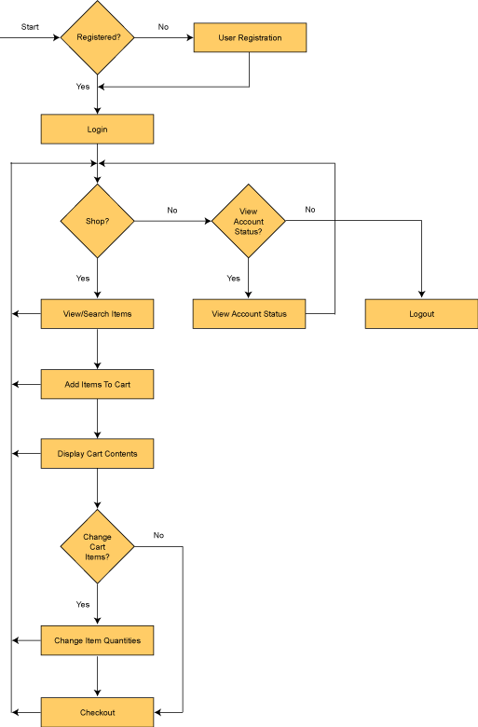

*Figure 10:* Customer shopping flow chat

# UML Diagram

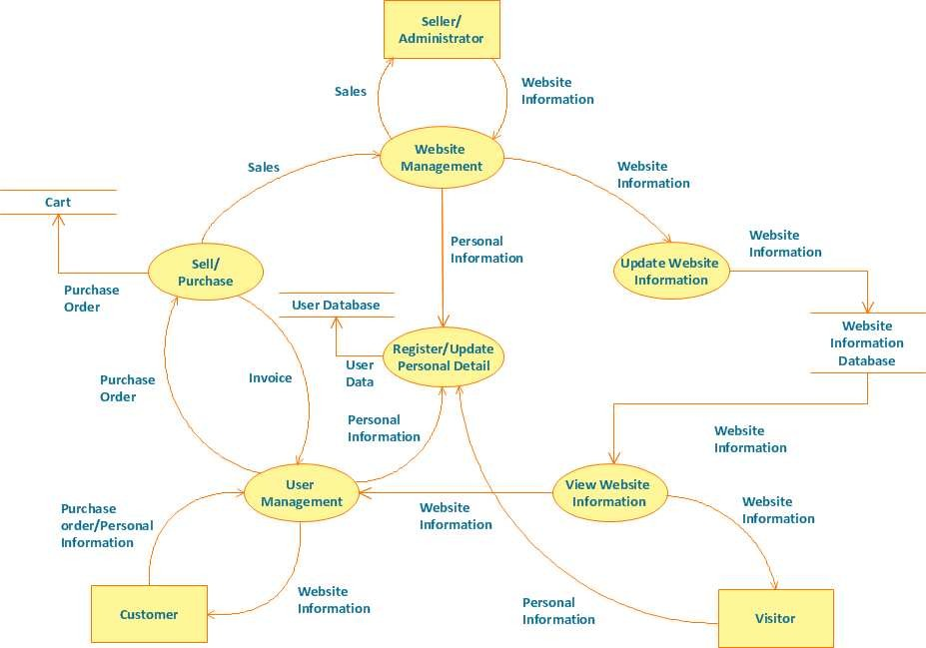

*Figure 11: UML Diagram*

# Data Design

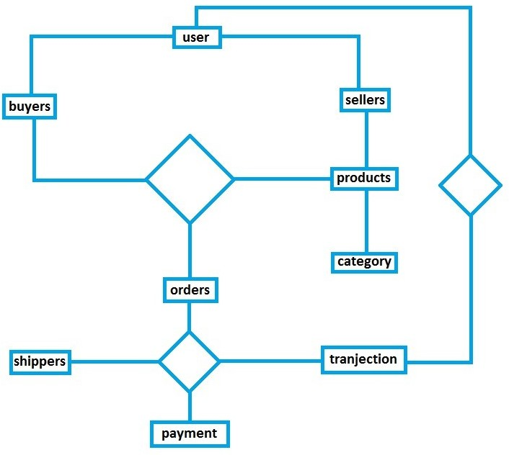

*Figure 12: Data Diagram*

# Data Relationships

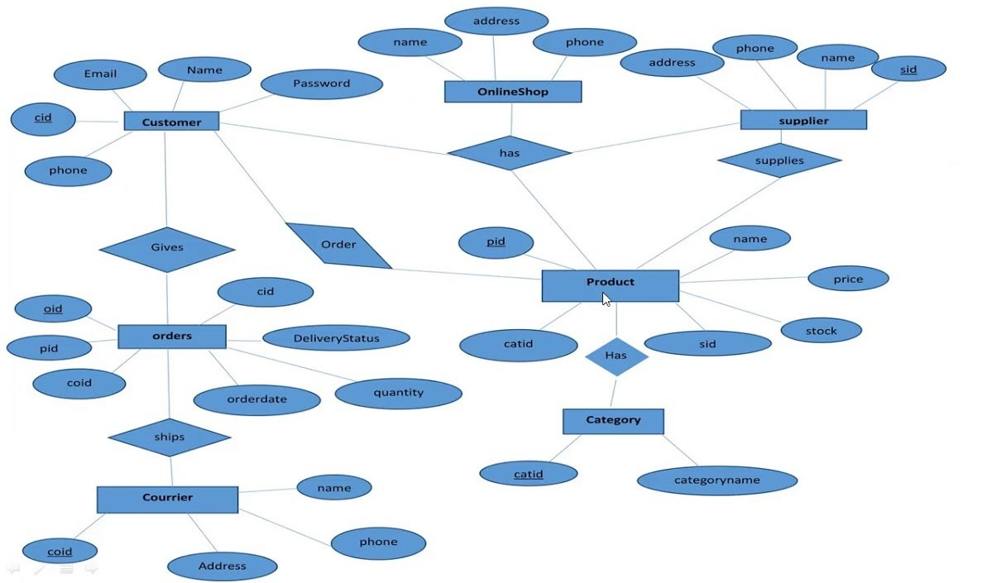

*Figure 13: Data Relationship Diagrams*

# CHAPTER FOUR

# RESULTS AND DISCUSION

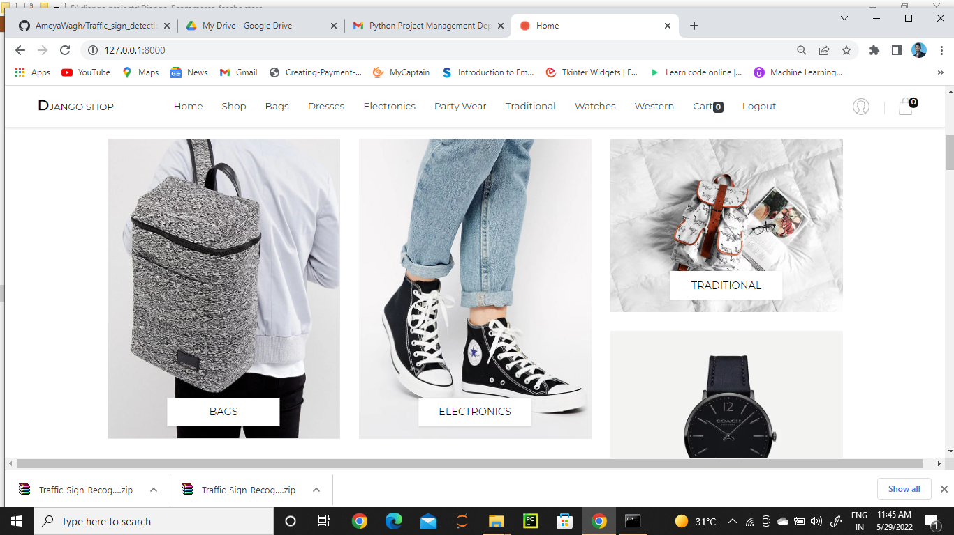

*Figure 14: interface*

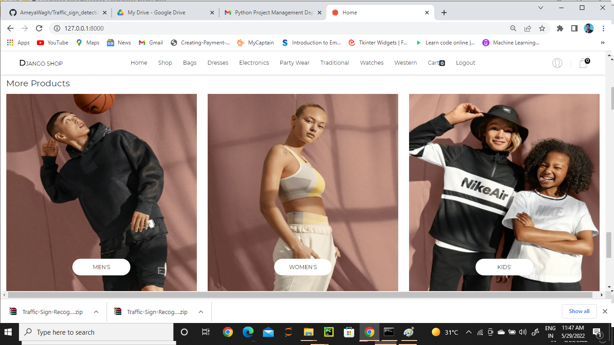

*Figure 15: items*

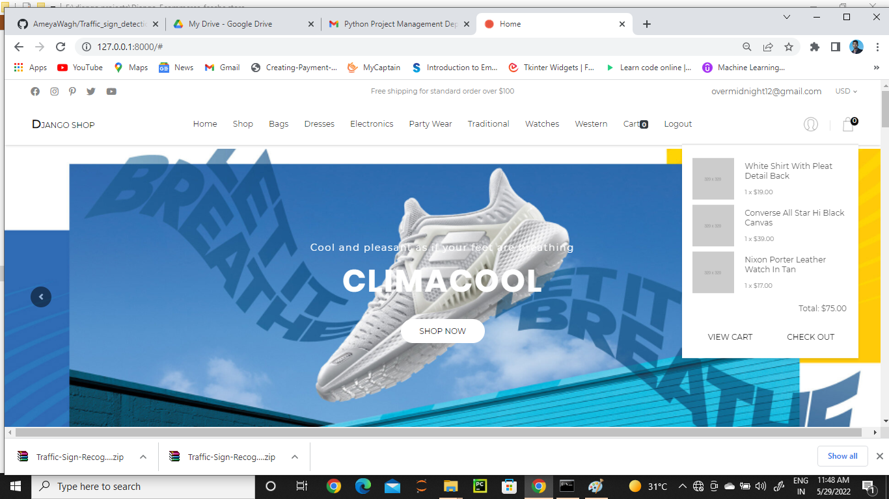

*Figure 16: Customer cat List*

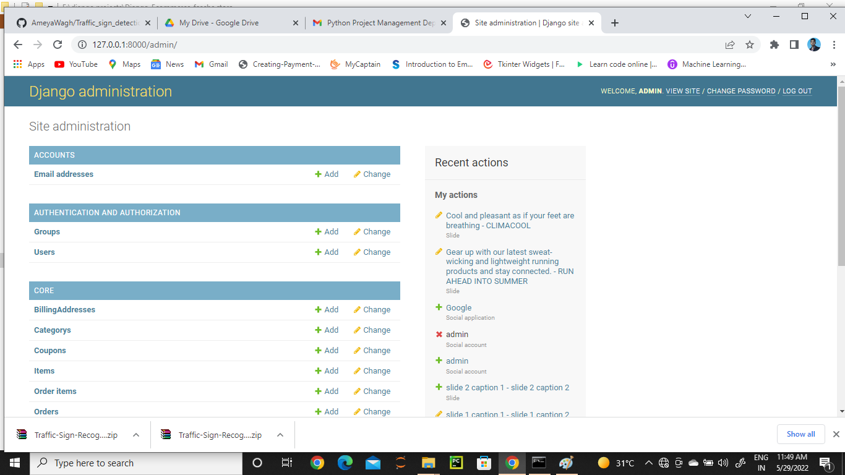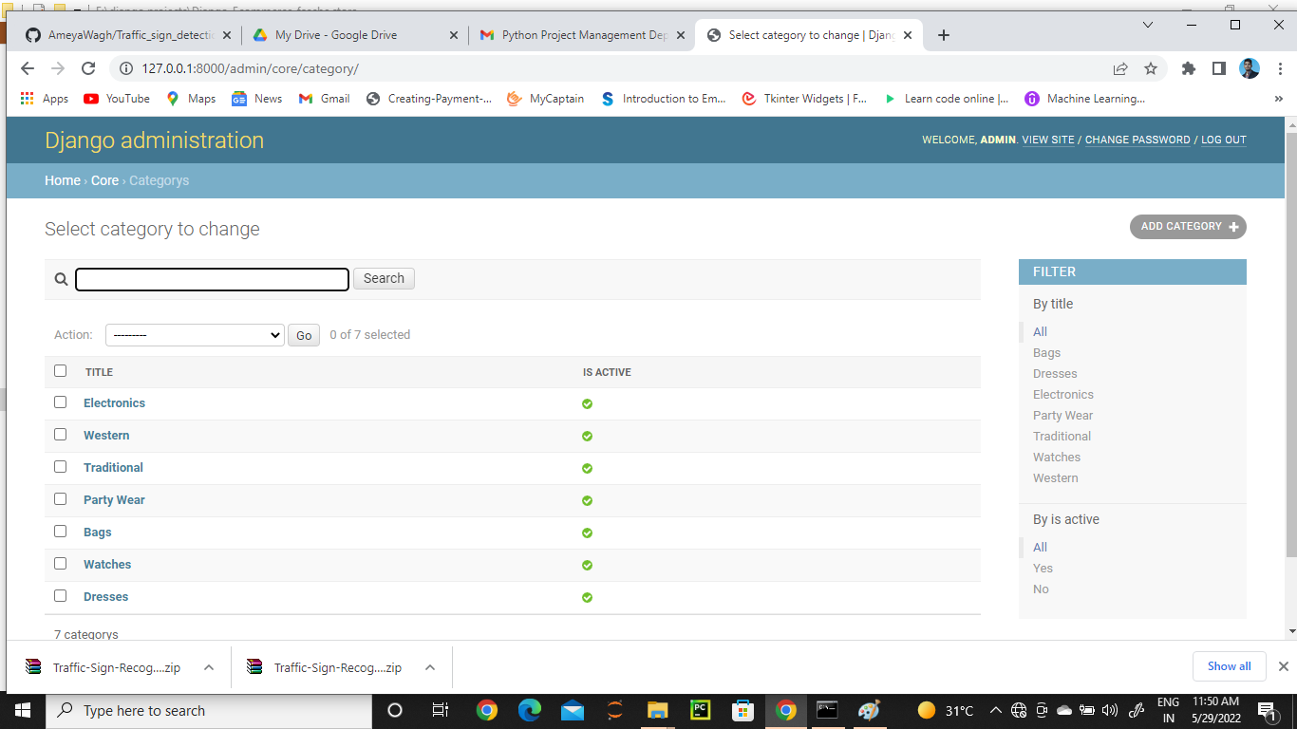

*Figure 17: Customer Admin Dashboard*

*It shows the total number of customers, total number of orders made and All available products*

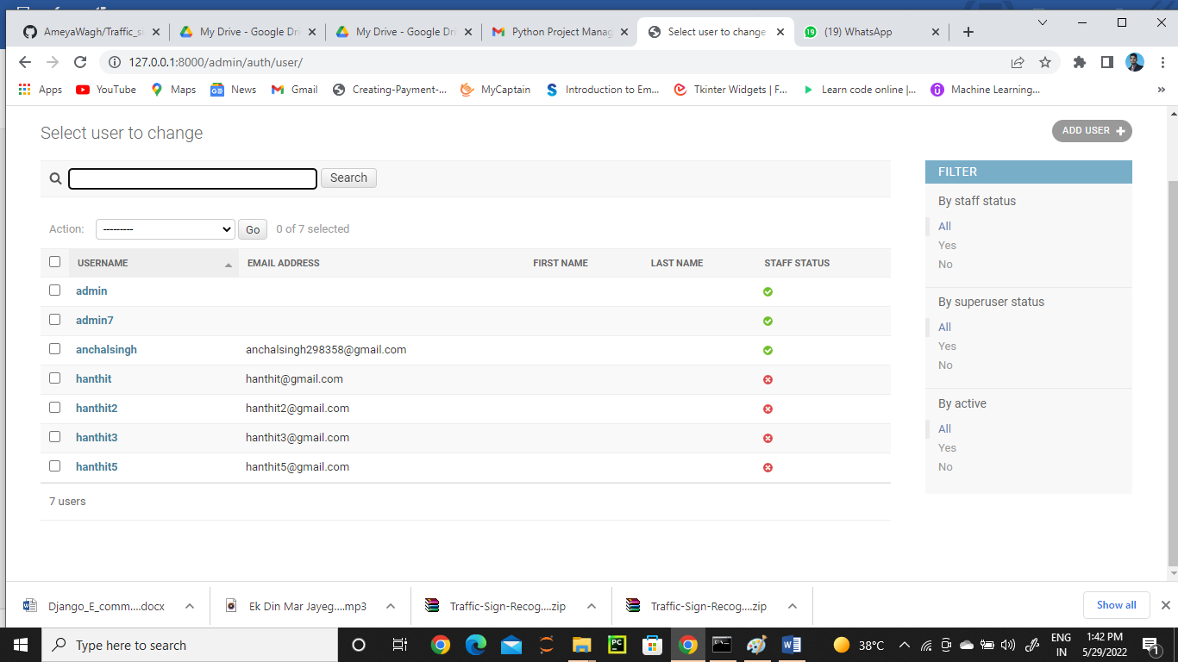

*Figure 18: List of all registered Customers*

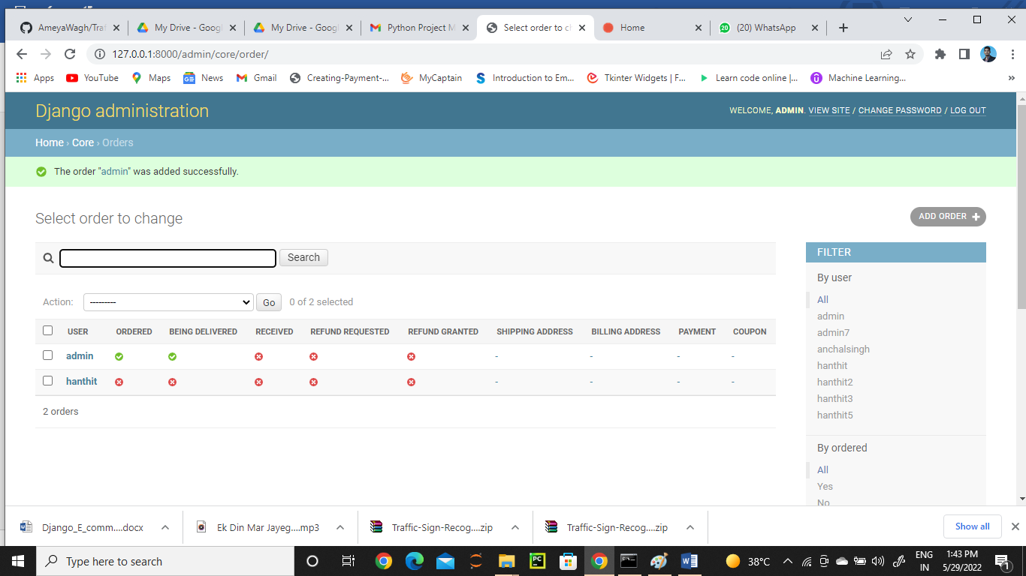

*Figure 19: List of all Orders Made*

*Admin can delete if detected as fake or update the status of the order*

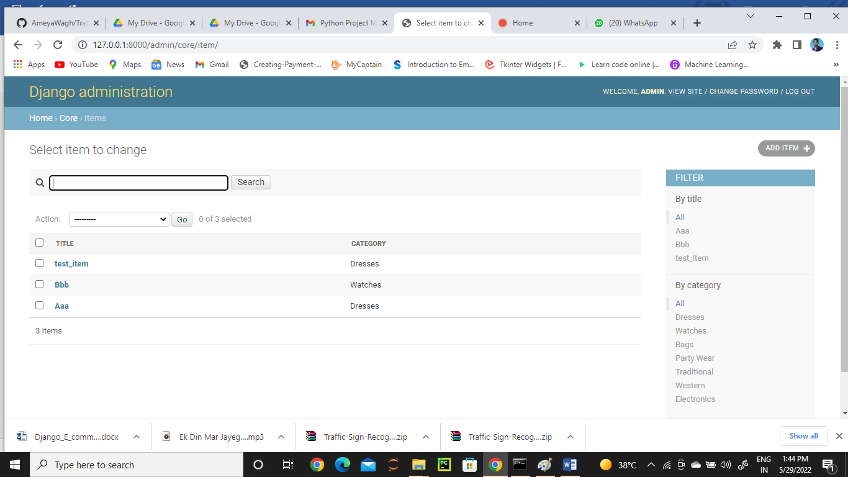

*Figure 20: List of all products in the system*

# CHAPTER FIVE

# CONCLUSION AND RECOMMENDATION

# CONCLUSION

The project entitled La BELLE Fashion Store system was completed successfully. The system has been developed with much care and free of errors and at the same time it is efficient and less time consuming. The purpose of this project was to develop a web application for purchasing items from a fashion shop. This project enabled me gain valuable information and practical knowledge on several topics like designing web pages using html & CSS, usage of responsive templates, designing of full stack Django application, and management of database using SQLite 3. The entire system is secured. Also, the project helped me understanding about the development phases of a project and software development life cycle. I learned how to test different features of a project. This project has given me great satisfaction in having designed an application which can be implemented to any nearby shops or branded shops selling various kinds of products by simple modifications. However, it was very challenging learning and developing an application using a new technology.

# RECOMMENDATION

There is a scope for further development in our project to a great extent. A number of features can be added to this system in future like providing. The feature like adding an authenticated payment system using Mpesa which is widely used in Kenya. Another feature we wished to implement was providing classes for customers so that different offers can be given to each class. System may keep track of history of purchases of each customer and provide suggestions

based on their history using Machine Learning Algorithm. These features could have been implemented if time and skills did not limit me.

# APPENDIX

# Project Log

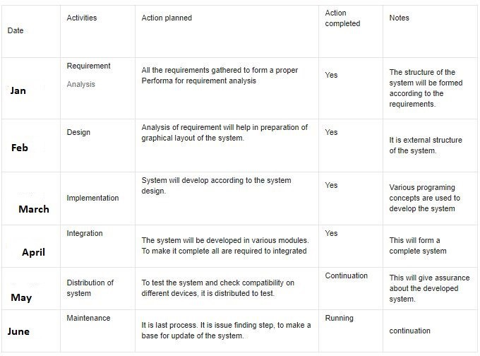

# Record of all procedures and Results

|  |  |
| --- | --- |
| **Registration** | This procedure allows the customers to sign in before making an order. Managers of  the website is created by system admin. |
| **Product** | This module contains the details of all products in the store. |

|  |  |
| --- | --- |
| **Price** | Manages Prices of products |
| **Shopping** | Manages the basic flow of orders. It’s the procedure by which a client places an order |
| **Payment** | Customer makes payment at this stage. However, this system does not have a real  payment system. |
| **Search** | Customers are able to search for specific product through this procedure |
| **Layout** | Customers view products from the homepage. They can Mouse over to display  product description. |
| **Reporting** | The customers are able to view and download their invoices. The system also  provides room form customer feedback |
| **Administration** | The system admin / business managers access the admin dashboard that allows them  to add products, view and confirm orders. |

# Structure of the Project Files

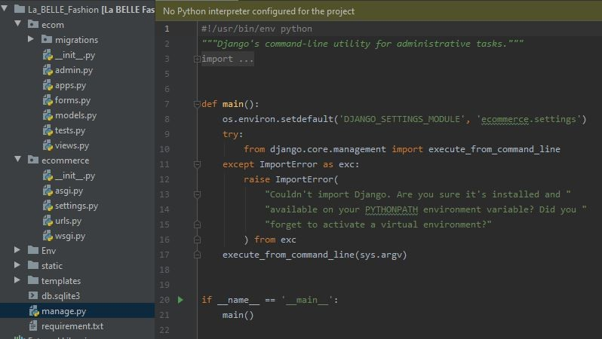

Django is a Model View Control (MVC) framework

* **Mange.py** -This file is used basically as a command-line utility and for deploying, debugging, or running our web application. It contains code for run-server, or make migrations or migrations, etc. that we use in the shell. Anyway, we do not need to make any changes to the file.
* **Db.sqlite3** is the database file.
* **Static** folder contains all the static files like CSS and images.
* **Env** folder is the project specific development environment. Its created through a command

*‘virtualenev Env’*

* **Ecomm folder** is the Django projects consisting of init, admin, models, views, apps and forms.
  + **Models** are basically the blueprints of the database we are using and hence contain the information regarding attributes and the fields etc of the database.
  + **Views** is a crucial one, it contains all the Views (usually as classes). Views.py can be considered as a file that interacts with the client. Views are a user interface for what we see when we render a Django Web application.
  + **URLs** Just like the project urls.py file, this file handles all the URLs of our web application.
* **Ecommerce** folder is the Django application directory consisting of the following essential files.
  + **Init.py** This file remains empty and is present them only to tell that this particular directory is a package.
  + **Settings.py** This file is present for adding all the applications and the middleware application present. Also, it has information about templates and databases. Overall, this is the main file of our Django web application.
  + **Urls.py** This file handles all the URLs of our web application. This file has the lists of all the endpoints that we will have for our website.
  + **Wsgi.py** This file mainly concerns with the WSGI server and is used for deploying our applications on to servers like Apache etc.
  + **Asgi.py** In the newer versions of Django, you will also find a file named as asgi.py apart from wsgi.py. ASGI can be considered as a succeeded interface to the WSGI. ASGI, short for Asynchronous Server Gateway interface.

# Templates Files

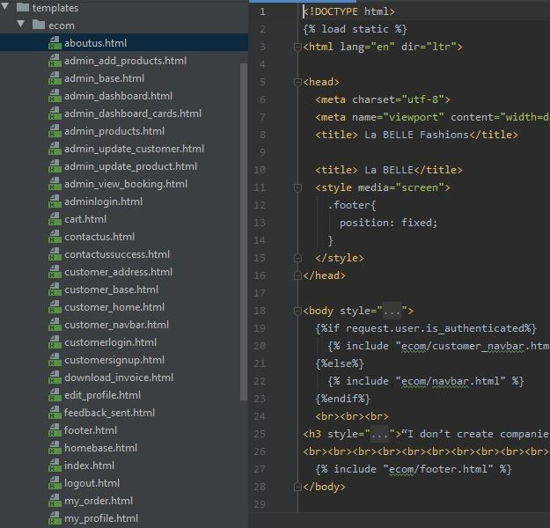

Templates Folder contains all the HTML files for the project

# REFERENCES

Fernandez, A.& Anthony D. Miyazaki. Consumer Perceptions of Privacy and Security Risks for Online Shopping. *The Journal of Consumer Affairs* 35.1: 27-44.

Kandra, A. (2001). The Myth of Secure E-shopping. *PC World July*: 29-32.

Halpin, M. (2011). 10 Things Your Mother Never Told You About Online Shopping. *Yahoo! Internet Life*: 61-63.

Wu, J., & Guo, X. (2011). Online booking system design and experimental realization. *2011 International Conference on Electrical and Control Engineering*. doi:10.1109/iceceng.2011.6057629

Kumar, V., & Singh, R. (2014). Women Online Shopping: A Critical Review of Literature. *SSRN Electronic Journal*. doi:10.2139/ssrn.2466824